**Migratory situation in August – Slight increase on main migratory routes**

2019-09-16

In August, the number of detections of illegal border crossings on Europe’s main migratory routes rose 9% from the previous month to around 12 900 due to higher arrivals on the Greek islands in the eastern Aegean. Overall, the total on all European migratory routes for the first eight months of 2019 was 26% lower than a year ago at around 68 700.

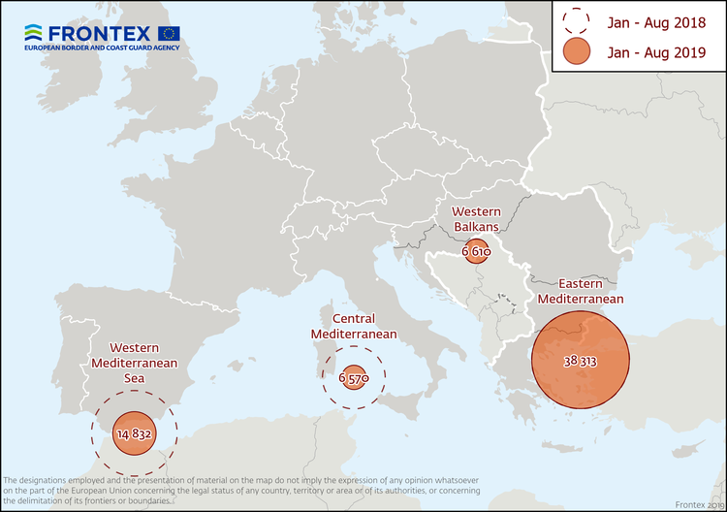

**Eastern Mediterranean**

There were nearly 9 300 detections in August 2019* on the Eastern Mediterranean route accounting for nearly three-quarters of the total number of irregular migrants reaching Europe. This was double the figure from the same month of last year due to a large number of boats reaching the Greek islands in eastern Aegean, especially Lesbos, in late August.

In the first eight months of this year, the total number of detections in this region was up 10% from a year ago to more than 38 300.

Afghans have accounted for two of every five migrants detected on this route.

**Western Mediterranean**

The number of irregular migrants crossing the Western Mediterranean by sea in August dropped 43% from the previous month to around 1 600.

The total for the January-August period stood at more than 14 800, around half the figure from the same period of last year.

People from sub-Saharan Africa accounted for the largest number of detected migrants on this route in the first eight months of 2019.

**Central Mediterranean**

The number of migrants passing through the Central Mediterranean in August stood at nearly 1 400, 8% more than in the previous month.

The total for the first eight months of the year reached nearly 6 600, slightly less than a third of the total from the same period of last year.

Tunisians, Sudanese and Pakistanis were the most represented nationalities on this route in the January-August period.

**Western Balkans**

There were nearly 400 detections of illegal border crossings recorded on this route in August. The total for the first eight months reached more than 6 600, 90% above the figure from a year ago.

Nationals of Afghanistan and Iran accounted for the largest share of migrants detected on this route.

*\*August 2019 data does not include the number of detections in Cyprus.*

*Note: The data presented in this statement refer to the number of detections of irregular border-crossing at the external borders of the European Union. The same person may attempt to cross the border several times in different locations at the external border.*